**Urban Agroecology Lab**

Eckerd’s urban farm provides us with a unique opportunity to better understand how urban agriculture affects insect populations’ presence. In this lab, we will be examining the differences in flying insect diversity and abundance between the orchard and farm section of Eckerd’s farm. Insects are important for an ecosystem’s success and have been called “biological foundation for all terrestrial ecosystems” (Scudder). This is because in their large numbers, they are able to very effectively maintain soil structure, polinate plants, and serve as a food source for other organisms. Their importance in an ecosystem’s biodiversity and health cannot be overstated. In it’s simplest terms, biodiversity is the variety of life in a particular ecosystem or habitat. In each of these ecosystems, all living things are highly dependent on each other- be it directly or indirectly. A healthy ecosystem is one that is diverse; one that has the ability to adapt and recover if a species has a population decline.

Greenspaces, such as urban farms, provide a habitat for many flying insects whose habitats have been otherwise destroyed by urbanization. This will, in turn, lead to a higher population of such species in these greenspaces. Pollinators, which are an integral part of agriculture, are expected to seek refuge in such areas (Sivakoff). Pollinators come in many different forms and sizes, from ants and bees to hummingbirds and bats, their contributions cannot be overstated. Pollinators are an integral part of all flowering plants’ lives, which includes many of the plants being grown on Eckerd’s urban farm (Celley). An urban farm is, as the name suggests, a farm within an urban environment. This would include patches of land used for food or flower production within a densely populated area with a lack of greenspace. The purpose of this study is to understand the diversity of insects on Eckerd’s campus and how the urban farm impacts that.

When conducting experiments in science, there is always an independent variable, dependent variable, and a control group. The independent variable is the condition being manipulated in the experiment. In our case, it is the presence of vegetation. The dependent variable is the factor that is being influenced by the change in the independent variable and is often what is being used to measure the change. For this lab, we are measuring insect biodiversity. Lastly, the control is the unchanged or unaffected variable. This lab uses a nearby rocky area to demonstrate an uncultivated landscape and will serve as a control for the study. A control is important because it allows us to confirm that the results from the study are due to the manipulated variable and not extraneous factors that we did not measure.

The **Shannon Diversity Index** **(H)** is a way to measure the diversity of species within a community. More specifically, it measures species evenness, which describes how similar species abundance is across the collected data. The index has a range of 0-1, with higher values indicating greater diversity. This equation assumes that all species are represented in a sample *and* that they are randomly sampled. In science we often stress the importance of accurate and thorough data, but this should exemplify why it is important. Incomplete or inaccurate data has the potential to give false results.

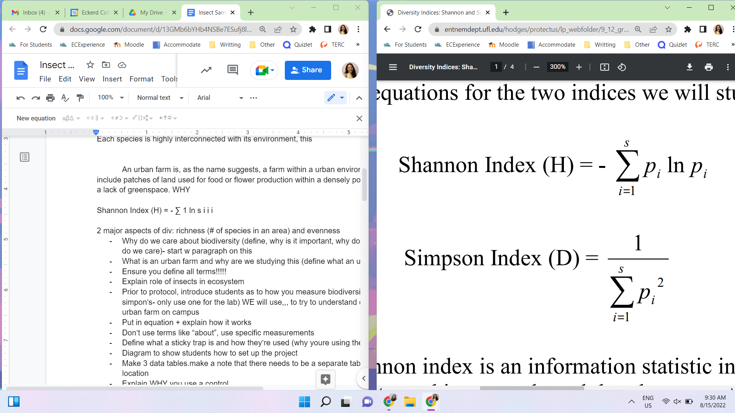

This is an equation with elements you’re likely familiar with. As a refresher, the **Σ** (sigma) indicates that you will sum the calculations of each of the species (denoted as **s** on top of the sigma). The **p** represents the proportion of individuals of one particular species found divided by the total number of individuals found. This is generally written as n/N when not in an equation. Lastly the natural log (**ln**) is a numerical algorithm whose properties, while interesting, are not integral to your understanding of this lab.

**Materials for this lab:**

Sticky trap- a paper-like object that is designed to catch insects by utilizing an extremely sticky substance that is present on both sides of the paper. This way, the insect’s bodies will be availible for identification.

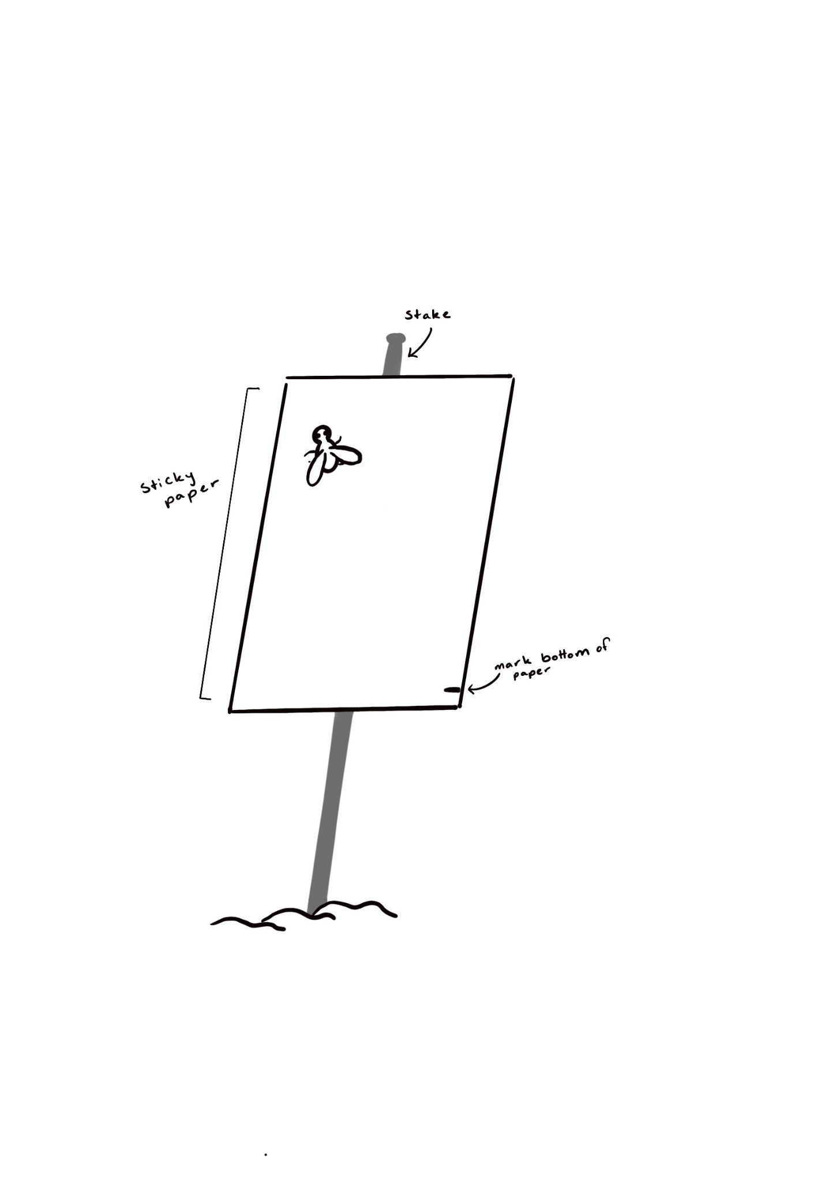

**For each of the three locations:**

1. Find an area within about a foot of foliage in the area you are sampling.
2. Mark your sticky trap with a black sharpie along the bottom edge to indicate which side is the bottom. This will be used in the data collection portion of this lab.
3. Set up a stake with a vertical sticky trap so that the top of the stake is 4’ from the ground. Ensure the sticky traps are perpendicular to the foliage to avoid leaves being caught on the traps.
4. Wait two hours for the trap to collect the insects, then retrieve the trap for examination

**Identification:**

1. Mark the lowest point of the flying insects’s body as their height
2. Identification will be based on visual observation. A catalog of insects previously found will be provided for quick identification. Use this to fill out the Order and Family sections
3. Provide the identifying characteristics that led you to the order and family you identified it as. Many of these characteristics can be similar, so take your time with these identifications.

**Data Collection**

Location: ORCHARD

|  | Height from ground | Order | Family | Reasoning |
| --- | --- | --- | --- | --- |
| 1 |  |  |  |  |
| 2 |  |  |  |  |
| 3 |  |  |  |  |
| 4 |  |  |  |  |

Location: RAISED BED

|  | Height from ground | Order | Family | Reasoning |
| --- | --- | --- | --- | --- |
| 1 |  |  |  |  |
| 2 |  |  |  |  |
| 3 |  |  |  |  |
| 4 |  |  |  |  |

Location: CONTROL

|  | Height from ground | Order | Family | Reasoning |
| --- | --- | --- | --- | --- |
| 1 |  |  |  |  |
| 2 |  |  |  |  |
| 3 |  |  |  |  |
| 4 |  |  |  |  |

**Data Analysis**

Class Data

| Species | Abundance |
| --- | --- |
| … |  |
| Sum | # of total individuals |

Using the equation H = -SUM (P * ln(P)), find the shannon’s index of your collected data. Below is a sample spreadsheet to help you.

In your own spreadsheet…

| Species | Abundance | p value | ln(p) | p*ln(p) |
| --- | --- | --- | --- | --- |
|  |  |  |  |  |

**Sources** Celley, Courtney. “Highlighting the Importance of Pollinators: U.S. Fish &amp; Wildlife Service.” FWS.gov, 14 Mar. 2022, https://www.fws.gov/story/highlighting-importance-pollinators.

Sivakoff, Frances, et al. “Unique Bee Communities Within Vacant Lots and Urban Farms Result from Variation in Surrounding Urbanization Intensity.” Sustainability, vol. 10, no. 6, MDPI AG, 2018, p. 1926–, <https://doi.org/10.3390/su10061926>

Scudder, Geoffrey G. E. “The Importance of Insects.” Insect Biodiversity, John Wiley & Sons, Ltd, 2017, pp. 9–43, https://doi.org/10.1002/9781118945568.ch2.